FAQs

Frequently Asked Questions
(In the order that questions are usually asked!)

- Can we order hot meals?
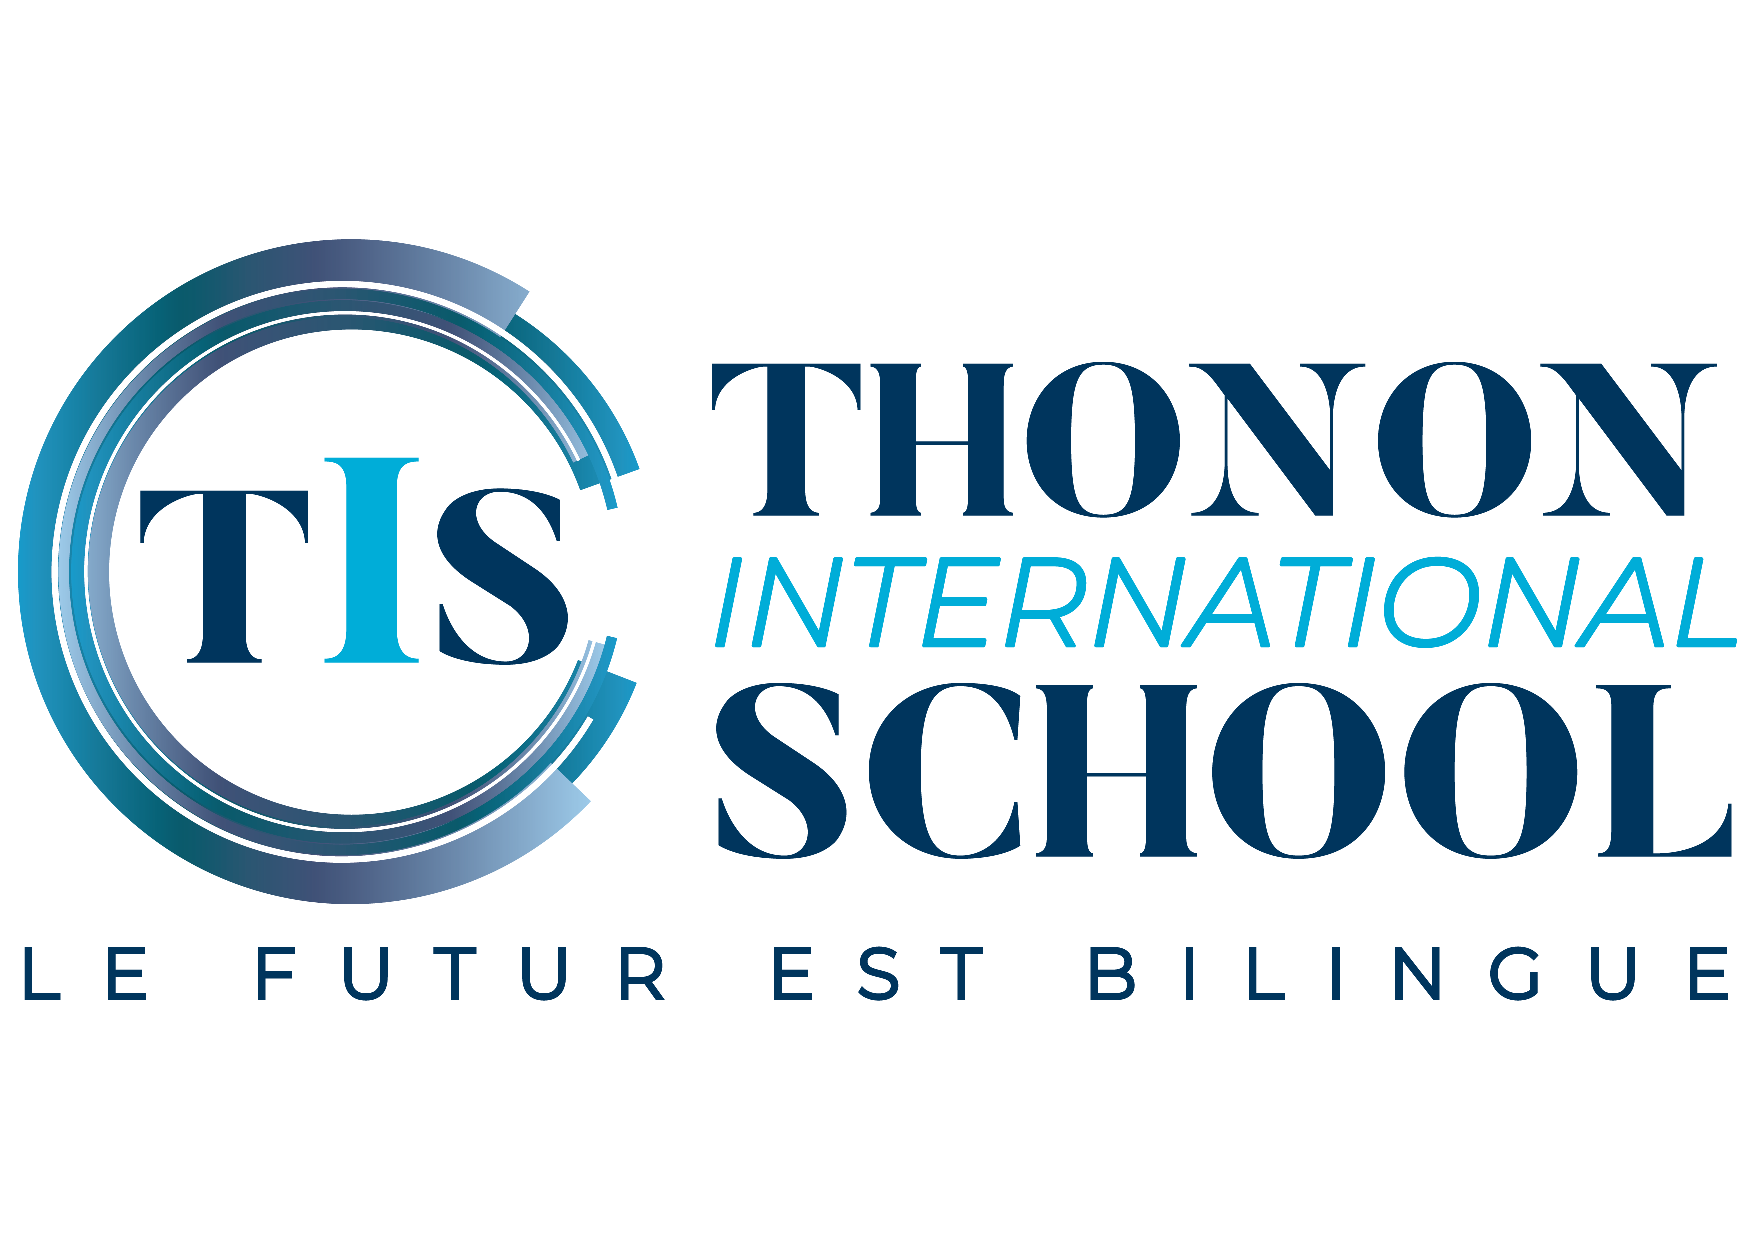

Yes. Parents have the choice of preparing a picnic at home or ordering hot meals which are delivered to the school daily. Children can also bring a meal that we can heat up at school.

- How many classes do you have?

Our school building has two large classrooms each measuring 30m2. We accept a maximum of 12 children per class. These classes are of mixed aged children: one class with Years 1, 2 and 3 and one class with Years 4, 5 and 6. Our school also has a separate canteen where the children eat with the teachers. Toilet facilities are separate for adults and children.

- How is sport organised?

Thonon International School does not have a playground and so has developed a partnership with the neighbouring Flydanse School in the same building, using its 160m2 hall for sporting activities indoors for the younger class. The older class uses the indoor facilities at Jean-Jacques Rousseau, a public school.

We also use the outdoor sports stadium at La Grangette, facilities maintained by the Sport’s Department of the Town Hall of Thonon-les-Bains. Here, children are able to take part in track and field events weekly. These facilities include on-site changing rooms.

Breaktimes also take place either in the Flydance halls or in nearby parks using the school minibus.

Two weeks of swimming lessons are organised at the beginning of each school year. Here children are given daily lessons at the local public swimming pool. Children leave the course with an official certification from the state.

- How is the bilingual programme organised?

The objective of Thonon International School is to provide a dual-language programme that allows a progression of language acquisition as children become older. At present, the two classroom facilities do not allow for one class for each year group of children, and so the programme is taught 50% in English and 50% in French. The content of the programme is based on the Education Nationale from France, but Thonon International School goes further than these objectives particularly concerning the individual approach to children’s needs.

- Is there a morning drop off and after school service?

Yes, details of which can be found on our website: https://www.ecoleintthonon.fr/en/cantine-and-after-school/

- Are your teachers qualified?

Yes ! All of our teachers have a minimum of one university degree and are experienced in teaching primary school children. All of our teachers are also at least bilingual in French and in English.

- How long has the school been open?

TIS received the authorisation from the Academy de Grenoble to open during the Summer of 2019 and opened its first class in September 2019. The enrollment has grown rapidly, despite the Covid pandemic, with 15 children enrolled during the 2020-21 school year in the primary school and 16 children attending the separate, Cambridge programme on Wednesdays.

- How can I pay for tuition?

Tuition and other fees may be settled by cheque or bank transfer. Bank details may be consulted with the school financial conditions described with the registration forms.

- Can I pay by instalments?

Tuition for the year is either paid in one instalment or by term. Payment is made in advance of each term.

- Where can I park?

There are four school parking places in front of the school. In addition, Flydanse has offered its parking spaces both in front of the building and behind for parents to use.

